# Information Visualization

# CHECKPOINT IV: First Prototype

G08-A

**1. Layout**

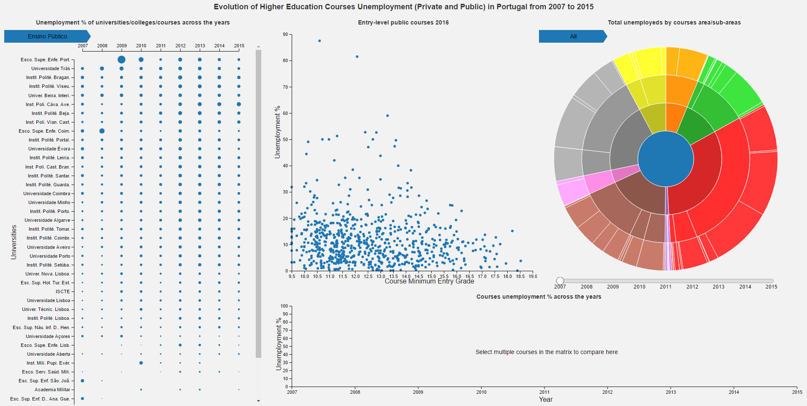

* The idiom at **left** is a **Bertin Matrix** with Universities in y-axis and the years in x-axis with interaction is possible drill down the data from University level to College level and from College level to course level. The circles are proportionally to the unemployment %.
* In the  **top-middle** is a **Scatter Plot** with unemployment % in y-axis, course minimum entry grade in x-axis. Each point represents a course.
* In **top-right** is a **Sunburst** that represents the quantity of unemployed people by courses area using the area of the “slice”. Course’s areas are hierarchical. Example: Artes e Humanidades -> [Artes, Humanidades], Artes -> [Belas Artes, Artesanato, Design,…]
* In the **bottom** is a **Line Chart** where is possible, with interaction, add courses to compare the unemployment % across the years of different courses.

**2. Implemented Idioms**

* + - 1. We have implemented the 4 idioms that we proposed, they are not fully completed, but they already have lots of interesting interactions.

**2.1 Bertin Matrix**

* + - 1. 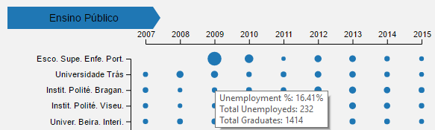It’s possible to see a tooltip when we hover a circle data to see the data details if the user is interested in knowing more about the data that generated that circle.

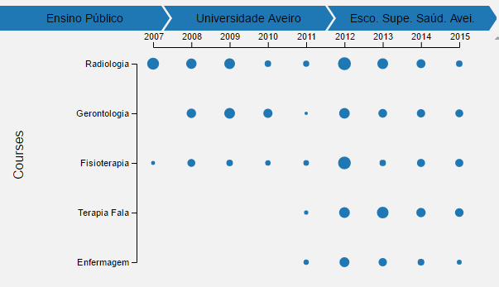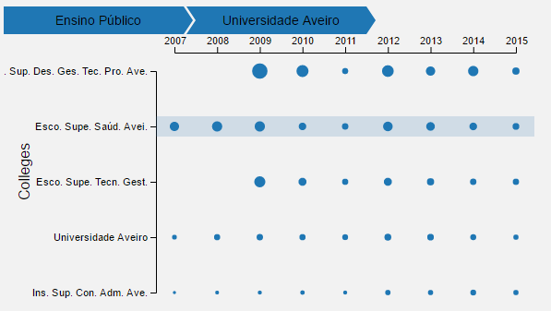

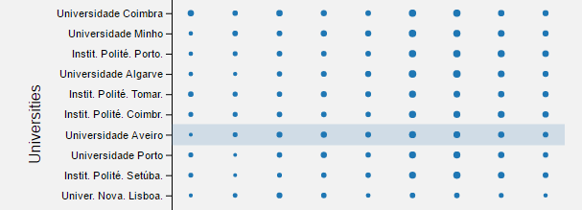

* In the images above is possible to see the drill down interaction in the matrix from “Universidade Aveiro” we went to all the colleges that belong to it and from “ESSA” we went to all the courses from “ESSA”.
* 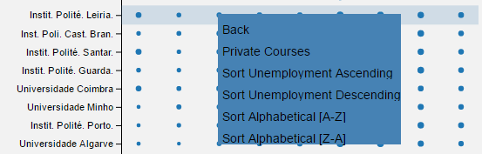We added “Breadcrumbs” in the top so the user can see where it is and maintain the context of the navigation, if we click in one of the breadcrumbs we can navigate to that College or University.
* 
* In the image at **above** at **left** we have a context menu to navigate to and to sort the data (by Unemployment and Alphabetical) that we are seeing.
* In the image **above** at **right** we can see in a tooltip the full name of the item, we can’t see it in all expanded in the visualization because some are very large.

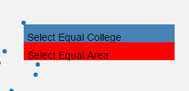**2.2 Scatter Plot**

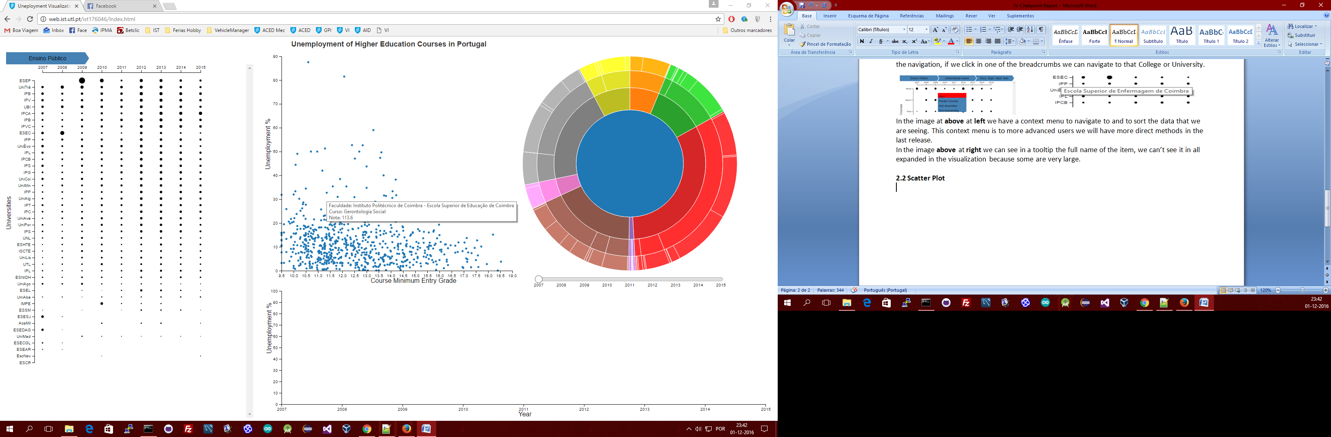

* As shown on above-left, Scatter plot has a tooltip to show the detailed data of a course (dot).
* By right-clicking in a dot, a menu will show and will activate Linked Interactivity -by colleges and/or Area that affect Bertin Matrix and Sunburst.

**2.3 Sunburst**

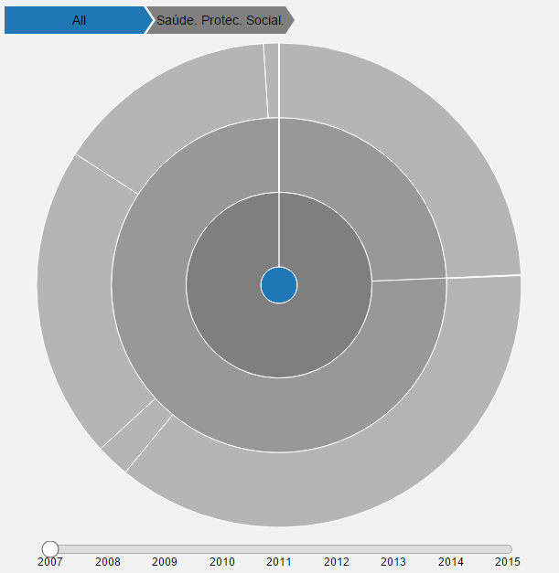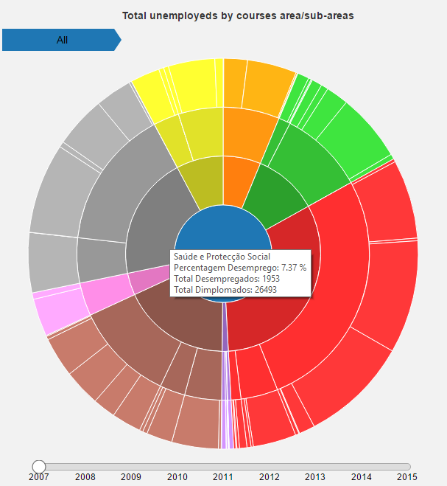

* The sunburst as tooltips for each area where it show the detailed information about the area as shown in the **above-left** image.
* We added “Breadcrumbs” in the top so the user can see the current area and maintain the context of the navigation, if we click in one of the breadcrumbs we can navigate to that Area.
* When we click in an area for example “Saúde e Protecção Social” we obtain the **above-right** image that is the zoomed area where user can compare the sub-areas more accurately.
* We have a slider in the bottom where we can select the year of the data shown by the sunburst.
* **Improvement:** We want to put labels inside the areas in the last release and get a better color schema do differentiate the areas and sub areas.

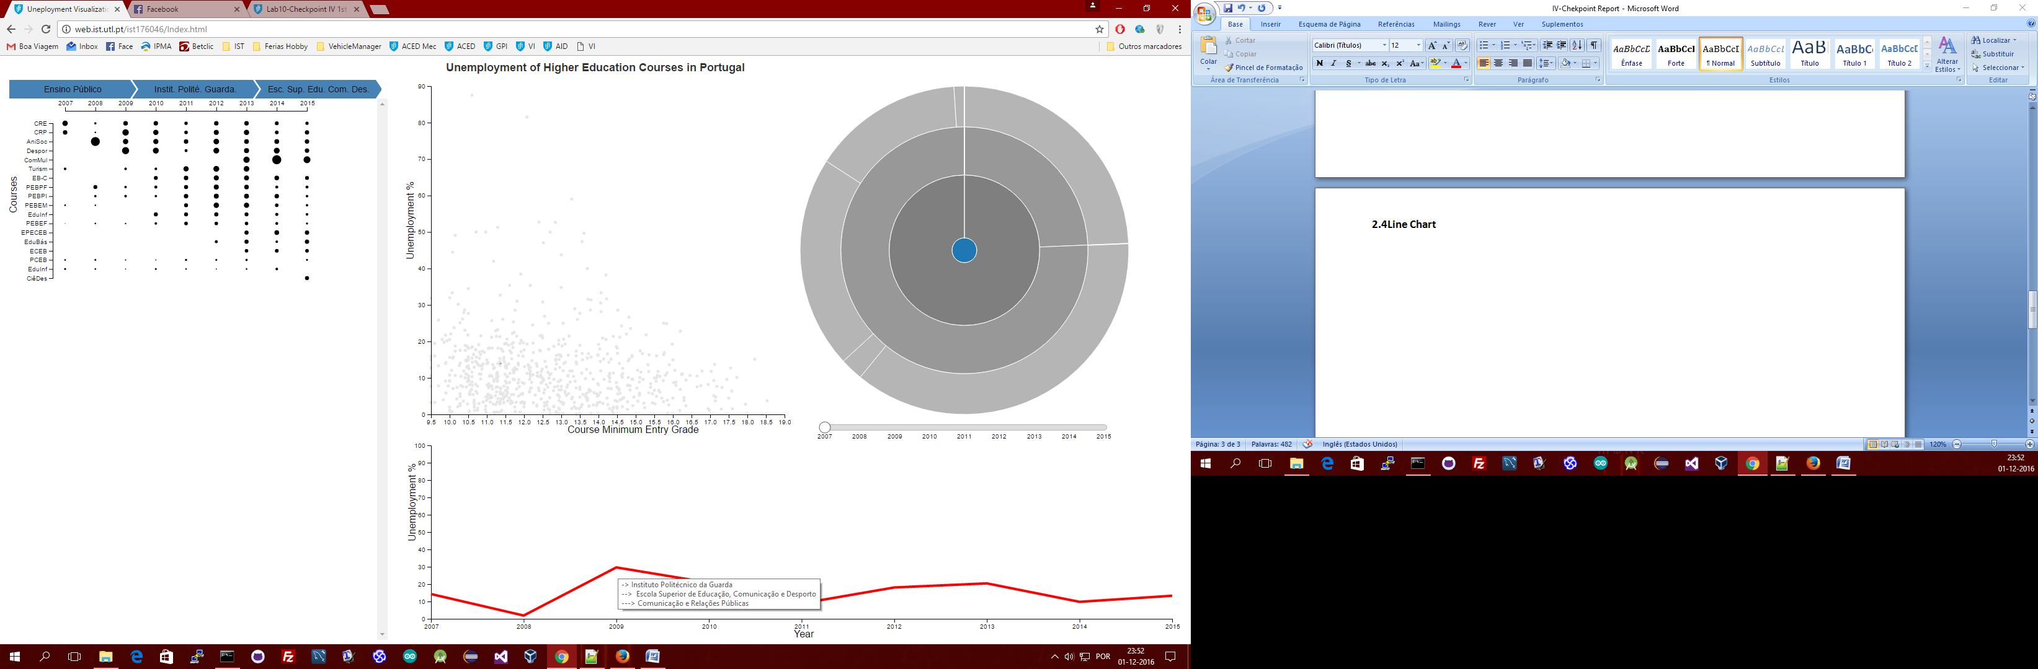**2.4 Line Chart**

* 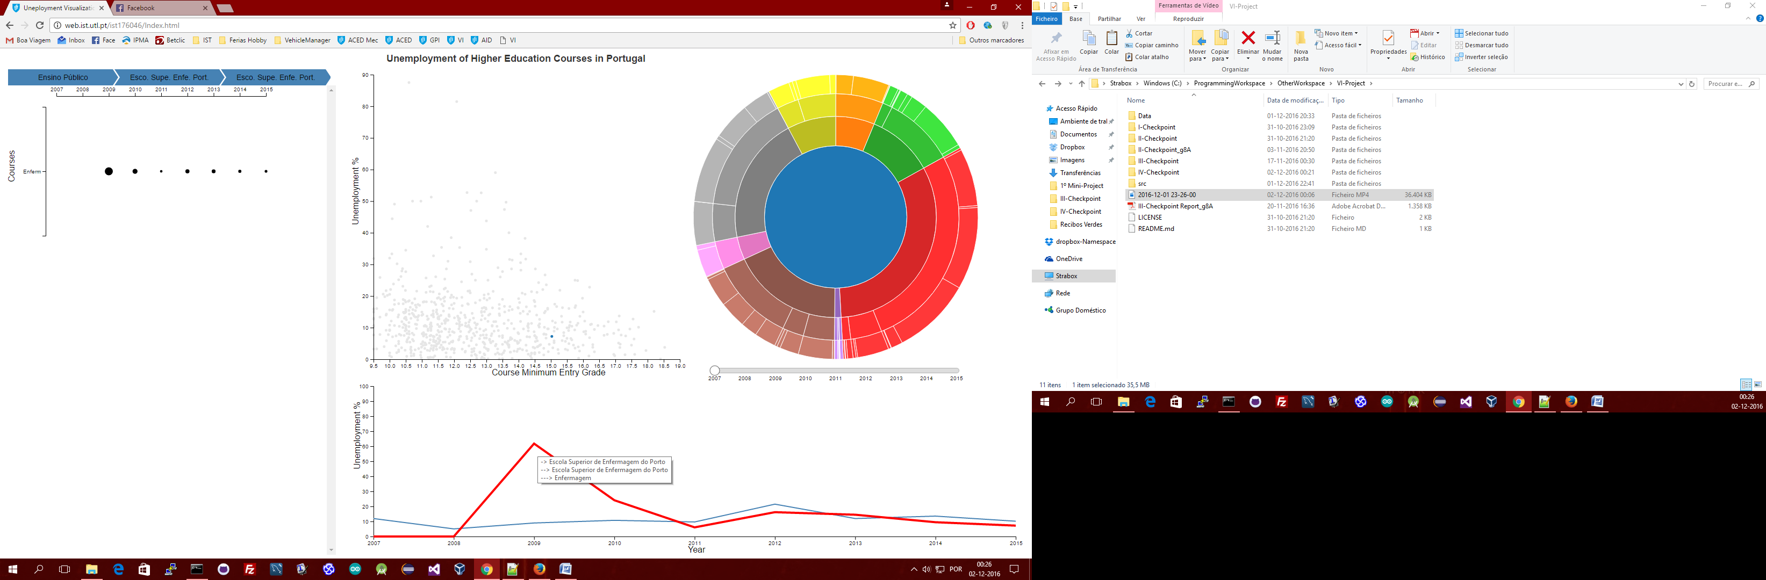This line obtained above only appeared in the line chart when we clicked in a course in the Bertin Matrix a tooltip here shows the course represented.
* The user can add multiple courses to the line chart with objective of making all the courses comparable.
* **Improvement:** This idiom is the one that need more improvement especially the link of colors with sunburst but we focused in Sunburst, Matrix and Scatter in this first release.

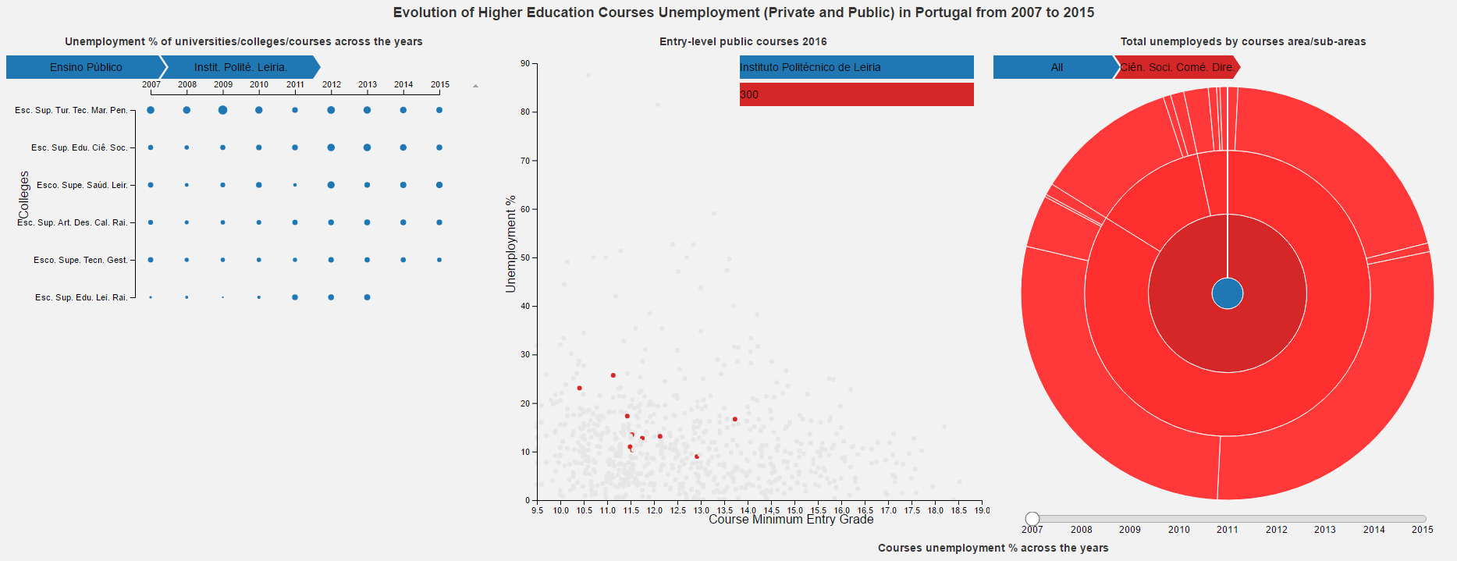**3. Linked Interactivity**

* As we can see in the image above the scatter plot, matrix and sunburst are completely linked.
* The dots shown in red are the courses from all the colleges of “Instituto Politécnico de Leiria” that belongs to the dark red area (the selected one) “Ciências Sociais, Comércio e Direito”. Basically the scatter plot dots are filter according to what we are seeing in matrix and in sunburst, it’s like a composition of filters.
* By clicking “Select Equal College” on a Scatter Plot dot, Bertin Matrix will “open” that college, creating a filter, bidirectional interaction Scatter Plot-Matrix.
* By clicking “Select Equal Area” on a Scatter Plot dot, Sunburst will zoom to that area, creating a filter, bidirectional interaction Scatter Plot-Sunburst.
* We maintain the dots that are not accepted by the “filter” (in a light grey) to show the general context.